The Baptism Scene: Morality vs. Murder

The Godfather (1972) directed by Francis Ford Coppola is one of the most recognizable movies in all of film history. Arguably one of the more famous scenes in the movie is “the baptism scene”, in which during the baptism of Michael Corleone’s nephew, the heads of the 5 rival families to the Corleone’s are murdered, as commanded by Michael himself. These two ideas, mortality and murder, in it of themselves are two deeply contrasting ideas however, there is much more to this scene that provides an elaboration.

The overall aesthetics of the actual baptism are very drab and almost lifeless. The church is cast in a very dull light, the only colors we see are varies shades of browns and yellows. The browns are almost expected because it’s a church and most tend to have wooden structures. The yellow hue, however, is very interesting as it provides a double meaning. For example, let’s compare the yellow lighting on the baby being baptized verses when it’s on Michael. Typically, the color yellow represents happiness, joy, positivity, etc. When we view the yellow light on the baby, these color interpretations make sense, as baptisms are typically joyous occasions.

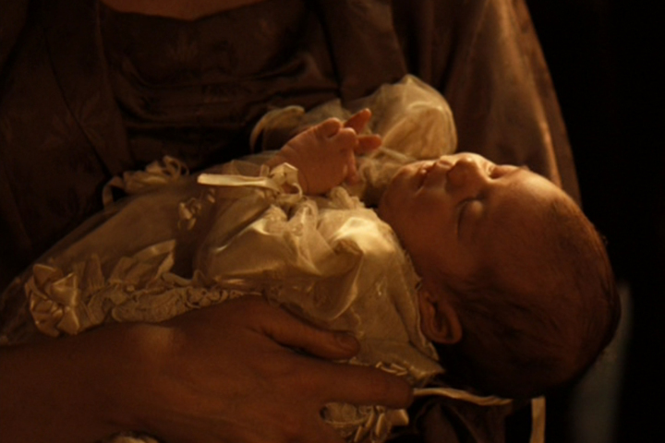

When the yellow light is cast on Michael however, instead of representing happiness it represents betrayal and deceit. Earlier in the movie, Michael’s brother was murdered, however his father vowed that he would not avenge the death of his son, thereby ending the war between the 5 families. This all changes when Michael becomes head of the family. He decided to carry out a plan to murder the heads of each of the families.



The use of both diegetic and non-diegetic sound also plays into these contrasting ideals of morality and murder. In the very beginning of the scene, we hear the baby crying and organ music, both being diegetic sounds which allude to what is actually happening on screen. The biggest use of non-diegetic sound is the organ music playing in the background of the men preparing for the murders. The music is very soft and light, like it is when you are in a church service, until the first murder happens. The music comes to its first crescendo and from then on whenever the music is playing in the background of the murders it is very loud and almost chaotic, representing the fact that we have moved away from religious beliefs and into the actions of the Corleone family. The fact that both are playing at the same time suggests the two sides of the family (religious and mafia participation) and when they try and co-exist, they heavily contradict each other.

Finally, the use of crosscut editing and montage physically show the duality between morality and murder. The greatest example of this is when Michael is proclaiming his vows. We watch the Priest ask Michael if he renounces Satan, believes in God etc. The scene then immediately cuts to a murder until ultimately cutting back to Michael answering, “I do”. The way in which this is edited shows Michael’s hypocrisy as he is renouncing evil, while at the same time the murders that he ordered are being carried out. This montage shows that both crime and religion are big parts of the Corleone family.

The cinematic techniques that Francis Ford Coppola uses to portray the idea of mortality vs. murder are quite vast. The yellow lighting suggesting Michael’s deceitfulness, the use of the non-diegetic sound of the organ music to suggest the two sides of the family, and the crosscut editing and montage portraying Michael’s hypocrisy all show different things but overall help to build one common theme.