Sarah Marie Adamson
sarah.adamson@spartans.ut.edu
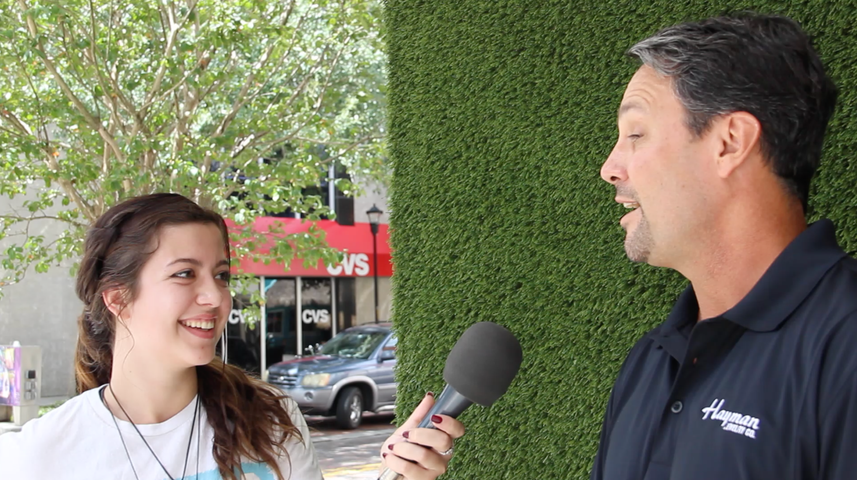
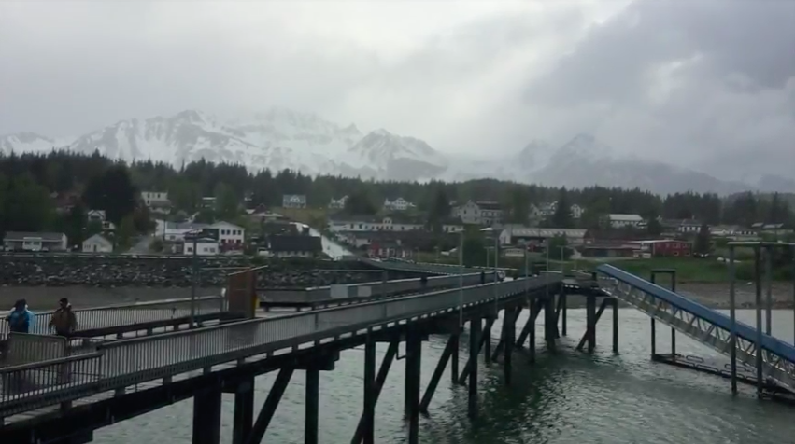
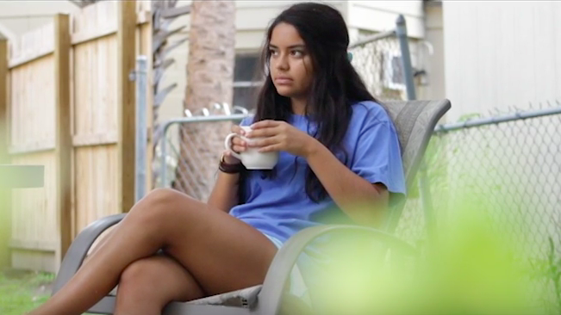
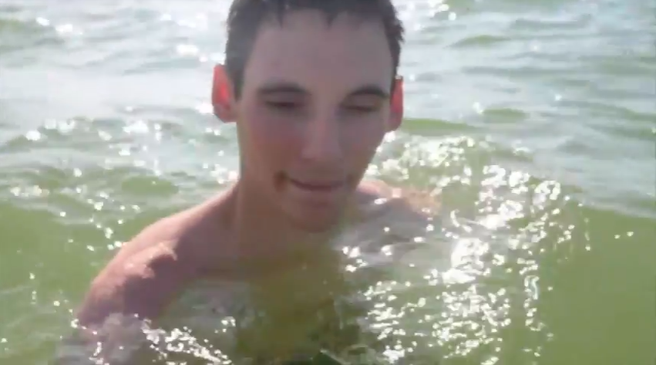
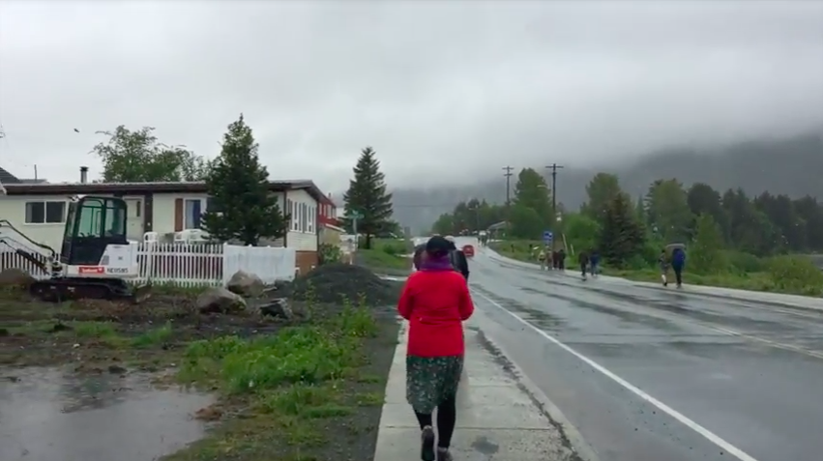
A

Adobe Premiere Adobe Photoshop Adobe Lightroom Adobe Illustrator
Social Media and Marketing Intern
June 2018 – Present | Aerial Innovations, Inc.
Work Experience

- Adobe Photoshop
- Adobe Lightroom
- MyEmma E-mail Campaigns
- SquareSpace

Social Media Intern - Aerial Photography
January 2018 – May 2018 | Go Bark Ball
www.aerialinnovations.com/aerial-articles-1/
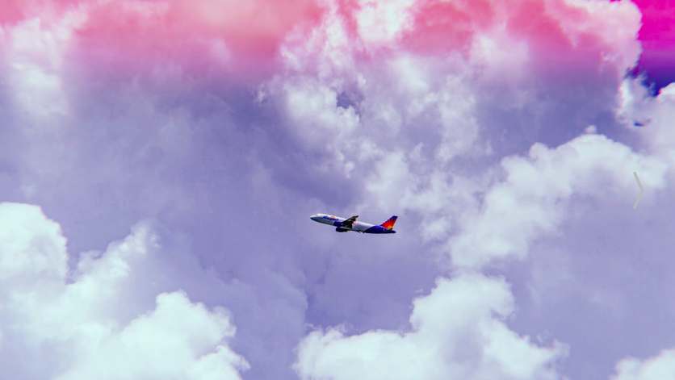
- HootSuite
- MailChimp
- Canva
- Commercial photography
www.gobarkball.com/blogs/the-bark

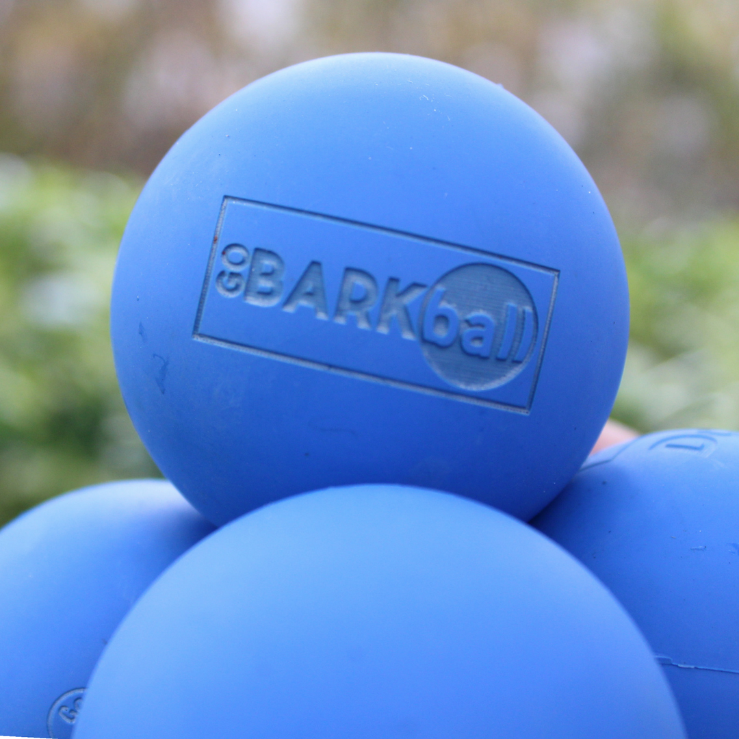
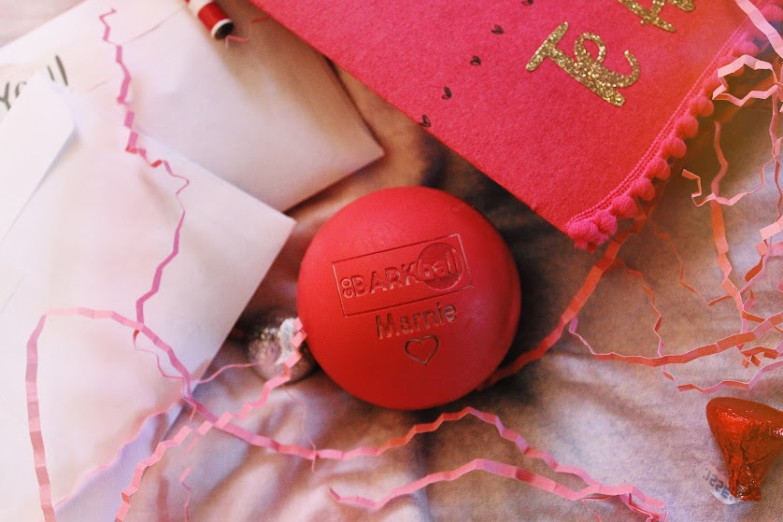

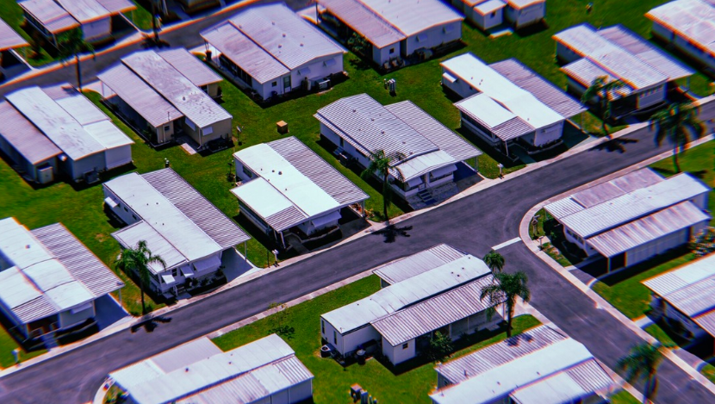

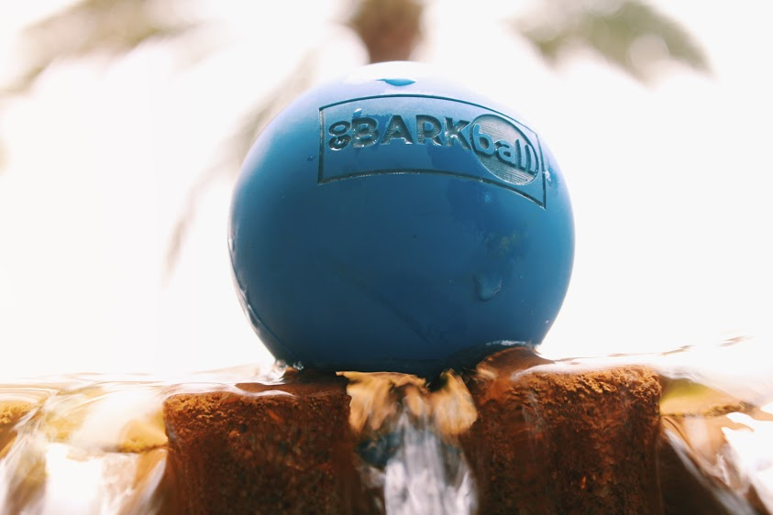

Education
BFA in Film and Media Arts
May 2020 | The University of Tampa

Leadership
Vice President
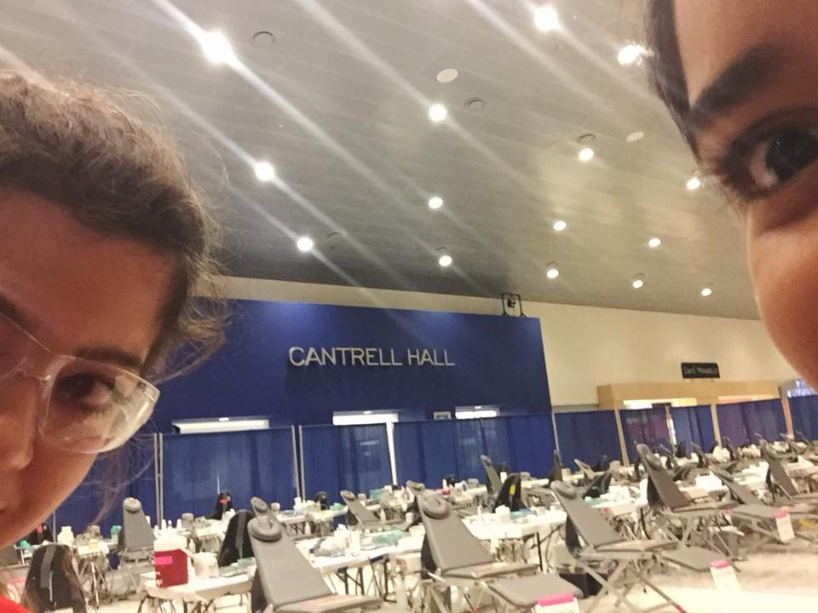
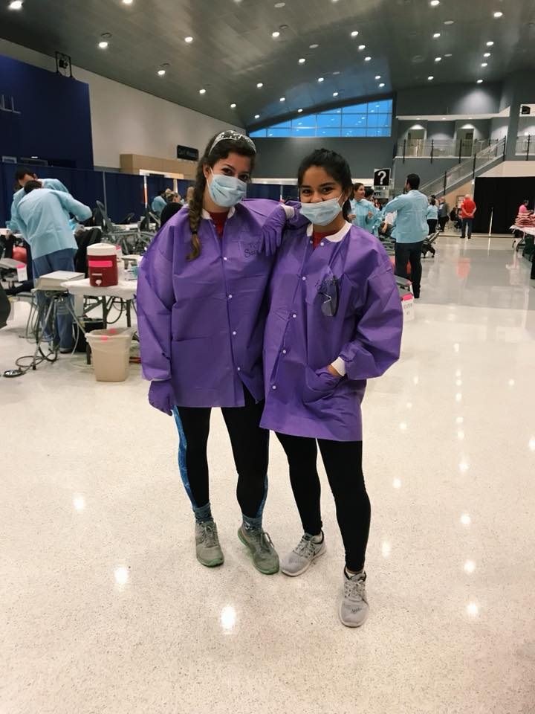
2018 – Present | UT Photo Club

Volunteer

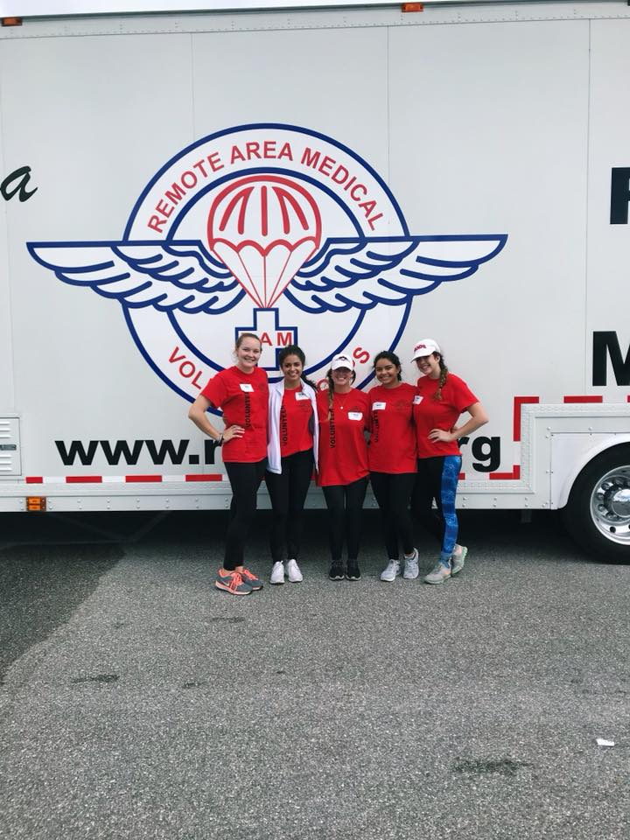

Remote Area Medical
November 2017 | Bradenton, FL

